Cholera Literature Review

**Inapparent infections and cholera dynamics** by Aaron King, et al.

<http://www.nature.com/nature/journal/v454/n7206/full/nature07084.html>

* Cholera, a bacterial pandemic disease, often produces symptoms mild enough to go unreported → can seriously compromise the interpretation of epidemiological records
* Understanding cholera transmission has been based upon assumptions about the ratio of asymptomatic to symptomatic infections and about the immunological consequences of inapparent infections
* Cholera has unsolved puzzles about its mode of transmission and the role of host immunity in its dynamics → this is due to the fact that in regions where cholera is endemic, most cases are mild or asymptomatic, but the true extent of asymptomatic infection has been difficult to assess
* They use a SIRS model that incorporates both transmission tied to human prevalence and transmission from environmental reservoir
* Prediction of the model found that immunity wanes on a timescale of weeks to months, which is in stark contrasts to the belief that cholera wanes on a timescale of 3 to 10 years
* Model also predicted low case fatality, but since fatality among hospitalized cases has historically been above 50%, this implies a very high asymptomatic ratio
* Seasonally averaged basic reproductive number, R0, for human associated transmission is estimated to be quite low → R0 = 1.5 +/- 0.2
* Hard to explain how cholera outbreaks can be so explosive at the outset and yet self-limiting to the point that sizable epidemics can recur twice annually → in the new view, epidemics are triggered by rising seasonal transmissiblity and the presence of a reservoir, but high asymptomatic ratio means that many more individuals are exposed. Vast majority receive short-term protection from infection so that depletion of the susceptible pool brings the epidemic to a halt. As immunity wanes, on timescale of weeks to months, susceptible pool is replenished and sets stage for new outbreak
* Studies that center on cholera patients can be expected to yield severely biased results when extrapolated to the population level, as they focus on the tail of the distribution of disease severity
* Most available data does not include direct measurement of inapparent infections, which greatly affects biological mechanisms underlying disease outbreaks

**Modeling cholera outbreaks** by Dennis L. Chao, et al.

<http://www.ncbi.nlm.nih.gov/pmc/articles/PMC4238032/>

* Recent massive and prolonged outbreaks of cholera in Haiti and several countries in Africa renewed interest in creating a global vaccine stockpile, however, there is lack of guidance in its use → modeling can help fill this gap
* Basic SIR framework can be adapted to specific infectious agents → for cholera, one could include an incubation period of a few hours to a few days, and an infectious period of one or two weeks. To include multi-season dynamics, waning immunity could be added (SIRS). One may also add symptomatic and asymptomatic infections.
* Many cholera models assume that individuals become infected by consumption of *V. cholerae* from the environment and have a specific compartment for it. Others have transmission terms that contain “person-to-person” and environmental transmission
* Cholera outbreaks are known to be fast and produce sharply peaked epidemic curves, but when case reporting is aggregated by large geographic regions, such as at country-level, sharp epidemic spikes and outbreak dynamics can be masked. Trying to fit a single epidemic curve to the aggregate of multiple spatially separated outbreaks will lead to misleading results.

**Modeling the Epidemiology of Cholera to Prevent Disease Transmission in Developing Countries** by Zindoga Mukandavire and J. Glenn Morris Jr.

<http://www.ncbi.nlm.nih.gov/pmc/articles/PMC4634708/>

* A key element of models of cholera transmission has been quantifying the basic reproductive number of disease transmission (R0) at regional level to assess possible geographic differences in disease dynamics
* Models also take into account potential differences in transmission related to “direct” transmission(human-to-human during short period of time when microorganism is “hyper-infectious” after passage in stool) versus “indirect” (environment-to-human)
* Model flow diagram used in study:

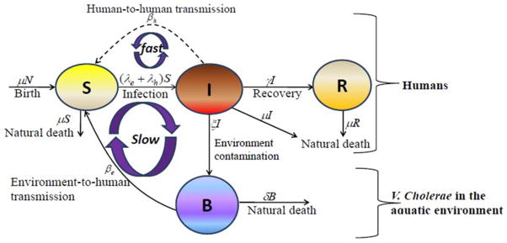

* Fit Zimbabwe and Haiti epidemic data to this model to estimate R0 values

- Zimbabwe: In general, human-to-human > environment-to-human and R range between 1.11- 2.72

- Haiti: In general, human-to-human > environment-to-human and R range between 1.06- 2.63

**Cholera Modeling: Challenges to Quantitative Analysis and Predicting the Impact of Interventions** by Yontan H. Grad, et al.

<http://www.ncbi.nlm.nih.gov/pmc/articles/PMC3380087/>

* In endemic situations, cholera transmission is influenced by complex factors, including multiple co-circulating strains, local immunity from past outbreaks, weather cycles, and phage that destroy *V. cholerae.* In epidemic outbreaks, many of these features are ignored → models assume a single infecting strain, entirely susceptible populations, and a short time scale for the epidemic such that climatic and phage-cholera relationships can be ignored
* Infection term in models suffer misspecification as there is no simple way to convert measurable quantities (i.e. a measured dose-response relationship between number of vibrios ingested and risk of infection) into parameters
* Epidemic curves in constituent spatial units may differ both temporally and in shape, such that aggregated epidemic curve incorporating each of these communities does not reflect homogeneous dynamics → R0 estimates from aggregated data fails to capture dynamics. Practice of fitting epidemic models to cumulative incidence curves rather than incidence curves can obscure features, and also violates statistical assumptions of independence between two data points
* Range of uncertainty that exists for cholera models (especially in duration of infectiousness in contaminated water) is very high, and thus uncertainty in just one parameter can nearly eliminate predictive powers of cholera models

**The Transmission Dynamics and Control of Cholera in Haiti: An Epidemic Model** by Jason R. Andrews, MD and Sanjay Basu, MD

<http://www.ncbi.nlm.nih.gov/pmc/articles/PMC3172163/>

* Model structure:

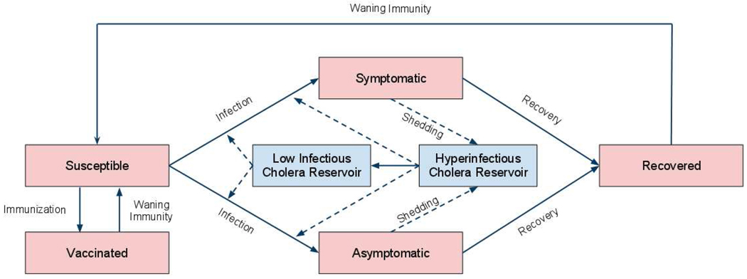

* Models were fit to daily reported hospitalized cases and total deaths from each province in Haiti. Key parameters of uncertainty were fit to the data (rate of contaminated water consumption, mortality rate from symptomatic cholera, and the concentration of cholera in environmental reservoir) and values were sampled using broad prior distributions using 100,000 iterations of Markov Chain Monte Carlo to estimate their posterior distributions by fitting the model to the data in each province
* Results showed that the predicted cases were underestimated by UN

**Cholera transmission dynamic models for public health practitioners** by Isaac Chun-Hai Fung

<http://www.ncbi.nlm.nih.gov/pmc/articles/PMC3926264/>

* Noting novel revealed

**Spatio-Temporal Dynamics of Cholera during the First Year of the Epidemic in Haiti** by Jean Gaudart, et al.

<http://www.ncbi.nlm.nih.gov/pmc/articles/PMC3617102/>

* Attack rates of the 2010 Haiti cholera epidemic reached highly heterogeneous levels between communes (from 64.7 to 3070.9 cases per 10,000 inhabitants)
* Low spatial autocorrelation and high degree of spatial heterogeneity of incident cases showed that outbreak dynamics in Haiti varied from location to location

**Modeling cholera epidemics: the role of waterways, human mobility and sanitation** by L. Mari, et al.

<http://www.ncbi.nlm.nih.gov/pmc/articles/PMC3243392/>

* Main source of water contamination during disease outbreaks is represented by fecal excretions of infected individuals, especially in regions where sanitation conditions are inadequate → hydrological controls are argued to play a crucial role in the spread of the disease
* Riverine corridors can propagate cholera pathogens from coastal to inland regions, and from inland epidemic sites to neighboring areas → spread of cholera epidemics through surface waters as a reactive transport process
* Human mobility: may be exposed to cholera in possibly infected destination sites and take disease back to possibly uninfected communities. May even be asymptomatic, yet still shed bacteria into their environment through feces and possibly infect other susceptible

**Understanding the cholera epidemic, Haiti** by Renaud Piarroux, et al.

<http://www.ncbi.nlm.nih.gov/pmc/articles/PMC3381400/>

* Nothing of use for project

**Hyperinfectivity: A Critical Element in the Ability of *V. cholerae* to Cause Epidemics?** By David M. Hartley, et al.

<http://www.ncbi.nlm.nih.gov/pmc/articles/PMC1298942/>

* Fundamental question regarding cholera epidemiology of cholera is: what is the relative importance of human-to-human versus environment-to-human transmission? Answering this question may allow one to predict onset and intensity of epidemic in endemic regions, as well as speed and intensity of the spread of cholera as it emerges in new regions
* Epidemic cholera is explosive in nature; when introduced into populations lacking prior immunity to the organism, spread through the population is measured in weeks, and involves all age groups
* Observations suggest that the passage of *V. cholerae* O1 Inaba El Tor (a common epidemic strain) through human GI track results in a short-lived hyper-infectious state → if such a state exists, it suggests that rapid local transmission through direct route is responsible for rapid spread and explosive nature of cholera epidemics

**Trends in Cholera Epidemiology** by Claudia T. Codeco and Flavio C. Coelho

<http://www.ncbi.nlm.nih.gov/pmc/articles/PMC1360632/>

* Two features of cholera outbreaks are puzzling: their almost simultaneous appearance in distinct areas (suggesting an environmental trigger) and their explosive nature
* Stool-derived bacteria always more successful than lab-cultured bacteria in colonizing the gut, reaching ratios as large as 700 stool-bacteria to one cultured bacteria → passage of *V. cholerae* through human gut would promote the expression of gene that makes bacteria more infective (only lasts about 18 hrs)

**Environmental signatures associated with cholera epidemics** by Guillaume Constantin de Magny

<http://www.ncbi.nlm.nih.gov/pmc/articles/PMC2584748/>

* It is now recognized that *V. cholerae* is a component of coastal and estuarine microbial ecosystems with the copepod species of zooplankton serving as host for the bacterium → ingestion of untreated water containing a relatively small number of copepods carrying *V. cholerae* can initiate the disease
* Distinct seasonal pattern of cholera, in countries where the disease is endemic, has been correlated with environmental factors and climate that drive both copepod population dynamics and seasonal peaks in abundance of *V. cholerae*

**Bayesian structured additive regression modeling of epidemic data: application to cholera** by Frank B. Osei, Alfred A. Duker, and Alfred Stein

<http://www.ncbi.nlm.nih.gov/pmc/articles/PMC3528434/>

* If standard statistical methods are used to analyze spatially correlated data, the standard error of the covariate parameters is underestimated and thus the statistical significance is overestimated
* Cholera outbreaks are enhanced by several environmental and socioeconomic risk factors: proximity to surface water/coastal areas, high population density, low education, low urbanization, poverty, and sanitation. No attempts have been made to combine all the identified measures of sanitation, including spatial effects, into a single multivariate model to examine their join effect on cholera

**Cholera Epidemic in Haiti, 2010: Using a Transmission Model to Explain Spatial Spread of Disease and Identify Optimal Control Interventions**  by Ashleigh R. Tuite, et al.

<http://annals.org/article.aspx?articleid=746949#Abstract>

* Interesting use of a gravity model

**On the predictive ability of mechanistic models for Haitian cholera epidemic** by Lorenzo Mari,et al

<http://www.ncbi.nlm.nih.gov/pmc/articles/PMC4345467/>

* Predictive models of epidemic cholera need to resolve at suitable aggregation levels spatial data pertaining to local communities, epidemiological records, hydrologic drivers, patterns of human mobility, and proxies of exposure rates
* Mathematical modeling of the ongoing cholera epidemic in Haiti has provided important insights concerning spatial transmission mechanisms, rainfall patterns, intervention strategies, local basic reproductive ratios, conditions for large-scale pathogen invasion, and probability of epidemic extinction
* Found that most models are able to reproduce complex spatio-temporal epidemic patterns during calibration, provided that the algorithm used for parameter fitting is given a sufficient amount of epidemiological data (exception is a model with lack of spatial coupling mechanisms, homogeneous parameters, and fixed initial conditions)
* As far as accurate spatio-temporal projections are concerned, spatially connected models seem to have a greater predictive ability than spatially disconnected ones
* Prediction of epidemic peaks are far from perfect for the models and calls for including process noise with stochastic modeling methods

**Social and News Media Enable Estimation of Epidemiological Patterns Early in 2010 Haitian Cholera Outbreak** by Rumi Chunara, et al.

<http://www.ncbi.nlm.nih.gov/pmc/articles/PMC3247107/>

* Data collected and reported through official public health institutions is often not available for weeks → examine data from two “informal” sources (HealthMap and Twitter) to determine whether the trend in volume over time of such reports would correlate with trend in volume of cases reported through official mechanisms over time → In 2010 Haiti cholera epidemic, a good correlation between informal and formal data exists
* Can use informal data collection early in an epidemic to try to estimate basic reproductive ratio
* Informal sources correlated best with official data with a one day lag, but is available in real time rather than with weeks of delays
* Loss of media attention throughout the stages of an epidemic shows that later time series data is not captured well by informal sources
* Important to note that informal data sources can contain a lot of biases

**Cholera transmission: the host, pathogen, and bacteriophage dynamic** by Eric J. Nelson, et al.

<http://www.ncbi.nlm.nih.gov/pmc/articles/PMC3842031/>

* Difficult to gauge the exact morbidity and mortality of cholera because the surveillance systems in many developing countries are rudimentary, and many countries are hesitant to report cases to WHO as they fear negative economic impact of disease on trade and tourism
* Following host ingestion of contaminated food or water, *V. cholerae* colonizes small intestine for 12 to 72 hrs before symptoms appear
* Distribution of symptomatic patients influences quantity of *V. cholerae* that is shed for subsequent transmission
* Several studies demonstrate that clinically apparent *V. cholerae* infection induces protective immunity against subsequent infections
* New models for cholera transmission should continue to include factors for seasonal variation, ratio of asymptomatic to symptomatic cases, and decay of protective immunity

**The incubation period of cholera: A systematic review** by Andrew S. Azman, et al.

<http://www.sciencedirect.com/science/article/pii/S0163445312003477>

* Whether an individual develops clinical cholera, and the time to the development of symptoms, depends upon mode of transmission, quantity of bacteria ingested, and host factors
* *V. cholerae* are classified into one of over 200 serogroups by their somatic O antigen, but only two serogroups, O1 and O139, are known to cause large outbreaks in humans
* More recently, estimates of the incubation period have been used to define the end of epidemics and to identify etiological relevant time periods to assess disease-associated risk factors → cholera models often utilize and assumed incubation period distribution
* Estimate the median incubation period of toxigenic cholera to be 1.4 days (95% CI 1.3-1.6) with a dispersion of 1.98 (95% CI 1.87-2.11). 5% of cholera cases will develop symptoms by 0.5 days (95% CI 0.4-0.5) and 95% by 4.4 days (95% CI 3.9-5.0) after infection

**Analyzing transmission dynamics of cholera with public health interventions** by Drew Posny, et al.

<http://www.sciencedirect.com/science/article/pii/S0025556415000656>

* Proposes a transmission model that includes public health interventions

**Endemic and epidemic dynamics of cholera: the role of the aquatic reservoir** by Claudia Codeco

<http://bmcinfectdis.biomedcentral.com/articles/10.1186/1471-2334-1-1>

* Once cholera enters a new region, we can expect three outcomes: no outbreak (cholera-free), an outbreak followed possibly by a few waves (epidemic), or a cholera outbreak followed by subsequent outbreaks that may assume a persistent seasonal pattern (endemic) → studies suggest that number of susceptibles, exposure to untreated water and sewage, and the presence of an aquatic reservoir of *V. cholerae* are important factors that drive these outcomes
* SIR model with aquatic reservoir

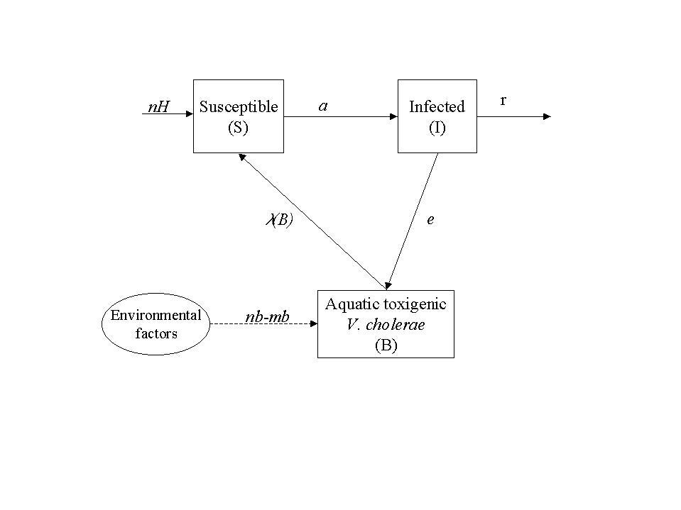

| Symbol | Description |
| --- | --- |
| State Variables |  |
| S | number of susceptibles |
| I | number of infected |
| B | concentration of toxigenic V. cholerae in water (cells/ml) |
| Parameters |  |
| H | total human population |
| n | Human birth and death rates (day-1) |
| a | rate of exposure to contaminated water (day-1) |
| K | concentration of V. cholerae in water that yields 50% chance of |
|  | catching cholera (cells/ml) |
| r | rate at which people recover from cholera (day-1) |
| nb | growth rate of V. cholerae in the aquatic environment (day-1) |
| mb | loss rate of V. cholerae in the aquatic environment (day-1) |
| e | contribution of each infected person to the population of V. cholerae |
|  | in the aquatic environment (cell/ml day-1 person-1) |

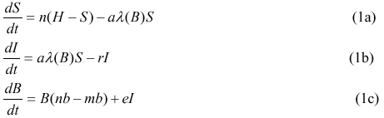

* Author notes that this is a very simple model that does not include many features of the complex system

**Identifiability and estimation of multiple transmission pathways in cholera and waterborne disease** by Marisa C. Eisenberg, et al.

<http://www.sciencedirect.com/science/article/pii/S0022519313000039>

* For cholera, a key epidemiological problem is distinguishing the relative contributions of disease transmission from human vs. environmental pathways → study to see whether or not parameters for SIWR models can be estimated from outbreak data
* Because many of the model parameters are not directly measurable, connecting disease models with outbreak data to yield predictive results requires a variety of parameter estimation, identifiability, and uncertainty quantification techniques
* Found that the SIWR model is structurally identifiable, however the two transmission pathway parameters are practically unidentifiable when indirect/water transmission timescale is fast
* Found that the SIWR model is not practically identifiable (presence of noise)

**Threshold dynamics for a cholera epidemic model with periodic transmission rate** by Xue-yong Zhou and Jin-an Cui

<http://www.sciencedirect.com/science/article/pii/S0307904X12004568>

* Formulates and analyzes a periodic cholera model

**On spatially explicit models of cholera epidemics** by E. Bertuzzo, et al.

<http://www.ncbi.nlm.nih.gov/pmc/articles/PMC2842613/>

* Infection is always caused by ingestion of water either contaminated by *V. cholerae* present in a natural reservoir (primary route) or contaminated by humans (secondary infection), and thus the role of the aquatic environment is crucial for the transmission as well as for the spreading of the disease